Networking Contd

## CIDR

 Expand 10.100.128.0/18

10.100.128.0/18

N (1) = 18

|  |  |  |  |
| --- | --- | --- | --- |
| n = | 32 - 18 = 14 | | |
| ip: | 10.100.10xxxxxx.xxxxxxx | | |
| sm: | 11111111.11111111.11000000.0000000 | | |
| start: | | 10.100.10000000.0000000 | = 10.100.128.0 |
| end: | | 10.100.10111111.1111111 | = 10.100.191.255 |

## Lets create a private network

 Private network

Lets create a private network for 190 devices

10.0.0.0/8 => 10.0.0.0 to 10.255.255.255

172.16.0.0/12 => 172.16.0.0 to 172.31.255.255

192.168.0.0/16 => 192.168.0.0 to 192.168.255.255

2^n - 2 ~= 190

2^n ~= 190

n = 8

N = 32 - 8 = 24

192.168.0.0/24

ip: 192.168.0.X

SM: 11111111.11111111.11111111.00000000

range: 192.168.0.0 to 192.168.0.255

Lets create a private network of size 1200 devices

|  |  |  |
| --- | --- | --- |
| 2^n | -2 | ~= 1200 |
| 2^n | ~= | 1200 |
| n = | 11 |  |
| N = | 32 | -11 = 21 |

Lets create a private network of size 67000 devices

ip: 172.16.0.0/21

172.16.00000xxx.0

SM: 11111111.11111111.11111000.00000000

range: 172.16.0.0 to 172.16.7.255

Lets create a private network of 100 devices

2^n ~= 67000

n = 17

N = 32 -17 = 15

ip: 10.0.0.0/15

10.0.0.0 to 10.1.255.255

2^n ~ = 100

n = 7

N = 25

ip: 192.168.0.0/25

192.168.0.128/25

192.168.1.0/25

192.168.1.128/25

..

192.168.255.0/25

10.100.101.128/25

172.17.200.128/25

ip ip:

a.b.c.dxxxxxxx

a.b.c.0xxxxxxx a.b.c.1xxxxxxx

SM: 11111111.11111111.11111111.10000000

# AWS Global INfrastructure

 Region

 Availability Zones  Local Zones

 Global Network

 Note: In AWS the private network which we will be creating is called as vpc (Virtual private cloud). VPC belongs to a region and in each AZ we can create subnets.

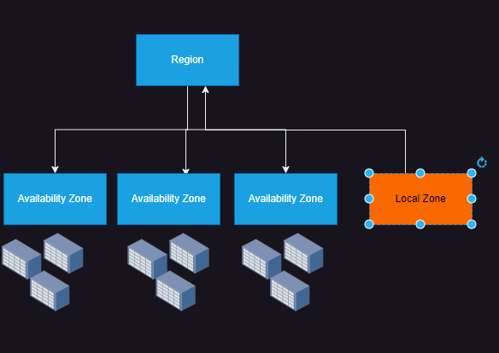

# Azure Global Infrastructure

 Region  Zone

 Backbone Network

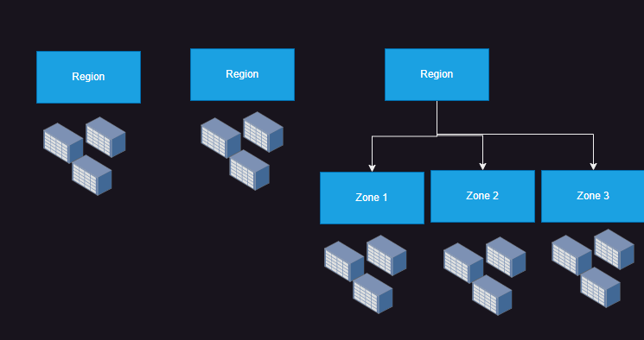 [Refer Here](https://datacenters.microsoft.com/globe/explore/) for microsoft data centers

 Note: In Azure the private network which we will be creating is called as Vnet (Virtual networks). Vnet belongs to a region and subnet also belongs to a region. Servers can only to added to subnets not

networks.

# Networks on cloud

 The networks which we create on cloud are virtual in nature.

 Since in the cloud, the resources are connected to subnets, we need to learn subnetting

# Subnetting

 Subnetting is breaking a large network into multiple smaller networks

## Scenario: Simple subnetting

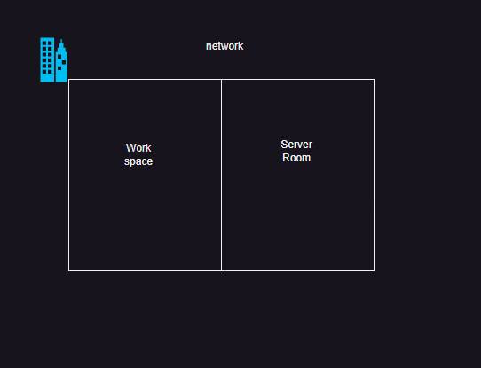 Consider the following case

 Organization has a need to connect 500 devices to a network  Server Room needs a subnet which will connect 250 servers

 Workspace needs to connect to 250 devices  Lets find cidr range for office network

Server room

# office

2^n - 2 ~= 500

n = 9

N = 23

office cidr 10.0.0.0/23

Workspace

2^n - 2 ~= 250

n = 8

N = 24

2^n - 2 ~= 250

n = 8

N = 24

Combine

nip: 10.0.0.0/23

nsm: 11111111.11111111.11111110.00000000

ssm: 11111111.11111111.11111111.00000000

X

10.0.0000000x.00000000

10.0.0.0/24

10.0.1.0/24